**BANK LOAN REPORT QUERY DOCUMENT**

1. **BANK LOAN REPORT | SUMMARY**

**KPI’s:**

**Total Loan Applications**

Select count(id) as total_application

from project..bank_loan_data;



**MTD Loan Applications**

select count(*) as mtd_loan_application

from project..financialloandata

where month(issue_date) = 12;

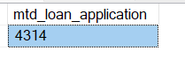

**Total Funded Amount**

Select sum(loan_amount) as total_loan_amount

From project..financialloandata;



**MTD Total Funded Amount**

Select sum(loan_amount) as MTD_total_loan_amount

From project..financialloandata

Where month(issue_date) = 12;

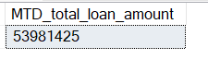

**PMTD Total Funded Amount**

select sum(loan_amount) as PMTD_total_loan_amount

from project..financialloandata

where month(issue_date) = 11;

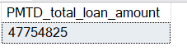

**Total Amount Received**

Select sum(total_payment) as total_amount_received

From project..financialloandata;

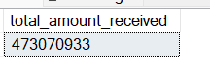

**MTD Total Amount Received**

Select sum(total_payment) as total_amount_received

From project..financialloandata

Where Month(issue_date) = 12;



**PMTD Total Amount Received**

Select sum(total_payment) as total_amount_received

From project..financialloandata

Where Month(issue_date) = 11;

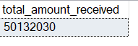

**Average Interest Rate**

Select Round(Avg(int_rate)*100,3) as Avg_Interest_Rate

From project..financialloandata;



**MTD Average Interest**

Select Round(Avg(int_rate)*100,3) as Avg_Interest_Rate

From project..financialloandata

Where Month(issue_date) = 12;



**PMTD Average Interest**

Select Round(Avg(int_rate)*100,3) as Avg_Interest_Rate

From project..financialloandata

Where Month(issue_date) = 11;



**Avg DTI**

SELECT Round(AVG(dti)*100,3) AS Avg_DTI

FROM project..financialloandata;



**MTD Avg DTI**

SELECT Round(AVG(dti)*100,3) AS MTD_Avg_DTI

FROM project..financialloandata

WHERE MONTH(issue_date) = 12;



**PMTD Avg DTI**

SELECT Round(AVG(dti)*100,3) AS PMTD_Avg_DTI

FROM project..financialloandata

WHERE MONTH(issue_date) = 11;



**GOOD LOAN ISSUED**

**Good Loan Percentage**

SELECT

ROUND(

(COUNT(CASE WHEN loan_status = 'Fully Paid' OR loan_status = 'Current' THEN id END)

* 100.0) / COUNT(id),3) AS good_loan_percentage

FROM project..financialloandata;



**Good Loan Applications**

Select count(*) as good_loan_application

From project..financialloandata

Where loan_status = 'Fully Paid' or loan_status = 'Current';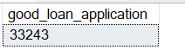

**Good Loan Funded Amount**

Select sum(loan_amount) as good_loan_amount

From project..financialloandata

Where loan_status = 'Fully Paid' or loan_status = 'Current';



**Good Loan Amount Received**

Select sum(total_payment) as good_loan_amount_received

From project..financialloandata

Where loan_status = 'Fully Paid' or loan_status = 'Current';



**BAD LOAN ISSUED**

**Bad Loan Percentage**

SELECT

(COUNT(CASE WHEN loan_status = 'Charged Off' THEN id END) * 100.0) /

COUNT(id) AS Bad_Loan_Percentage

From project..financialloandata



**Bad Loan Applications**

SELECT COUNT(id) AS Bad_Loan_Applications

From project..financialloandata

WHERE loan_status = 'Charged Off'



**Bad Loan Funded Amount**

SELECT SUM(loan_amount) AS Bad_Loan_Funded_amount

From project..financialloandata

WHERE loan_status = 'Charged Off'



**Bad Loan Amount Received**

SELECT SUM(total_payment) AS Bad_Loan_amount_received

From project..financialloandata

WHERE loan_status = 'Charged Off'



**LOAN STATUS**

Select loan_status,

count(loan_status) as total_loan_status,

sum(loan_amount) as total_loan_amount,

sum(total_payment) as total_amount_received,

Round(AVG(int_rate)*100,3) as AVG_interest_rate,

Round(AVG(dti)*100,3) as AVG_dti

From project..financialloandata

Group by loan_status;

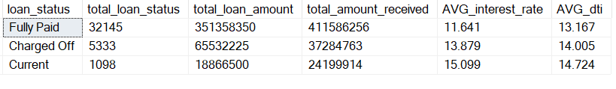

**MTD Loan Status**

Select loan_status,

count(loan_status) as total_loan_status,

sum(loan_amount) as total_loan_amount,

sum(total_payment) as total_amount_received,

Round(AVG(int_rate)*100,3) as AVG_interest_rate,

Round(AVG(dti)*100,3) as AVG_dti

From project..financialloandata

Where Month(issue_date) = 12

Group by loan_status;

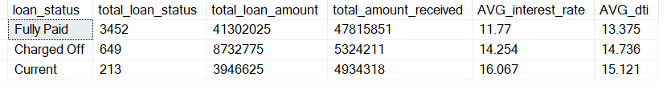

**BANK LOAN REPORT | OVERVIEW**

Select

Month(issue_date) as Month_Number,

DATENAME(Month,issue_date) as [Month],

count(id) as total_application,

sum(loan_amount) as Total_Loan_amount,

sum(total_payment) as Total_Amount_Received

From project..financialloandata

Group by Month(issue_date),DATENAME(Month,issue_date)

Order by Month(issue_date);

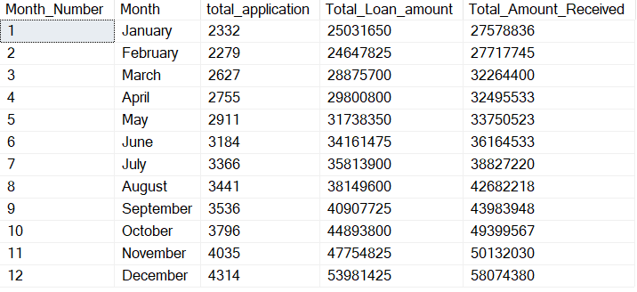

**STATE**

Select address_state,

count(id) as total_application,

sum(loan_amount) as Total_Loan_amount,

sum(total_payment) as Total_Amount_Received

From project..financialloandata

Group by address_state

Order by address_state;

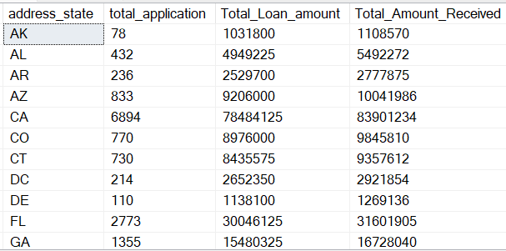

**EMPLOYEE LENGTH**

Select emp_length,

count(id) as total_application,

sum(loan_amount) as Total_Loan_amount,

sum(total_payment) as Total_Amount_Received

From project..financialloandata

Group by emp_length

Order by emp_length;

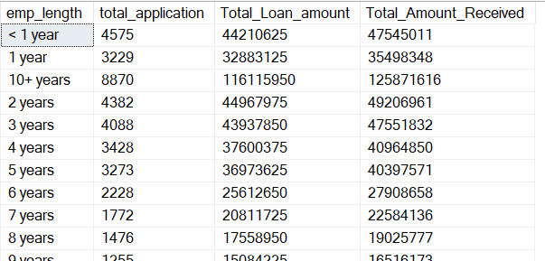

**PURPOSE**

Select purpose,

count(id) as total_application,

sum(loan_amount) as Total_Loan_amount,

sum(total_payment) as Total_Amount_Received

From project..financialloandata

Group by purpose

Order by purpose;

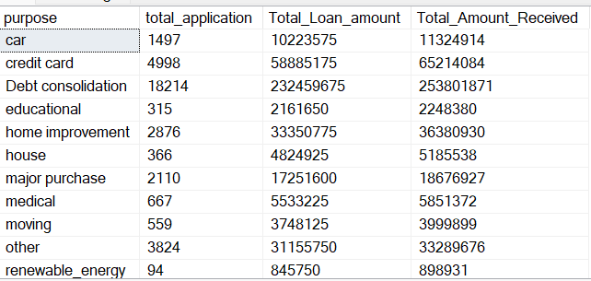

**HOME OWNERSHIP**

Select home_ownership,

count(id) as total_application,

sum(loan_amount) as Total_Loan_amount,

sum(total_payment) as Total_Amount_Received

From project..financialloandata

Group by home_ownership

Order by home_ownership;

